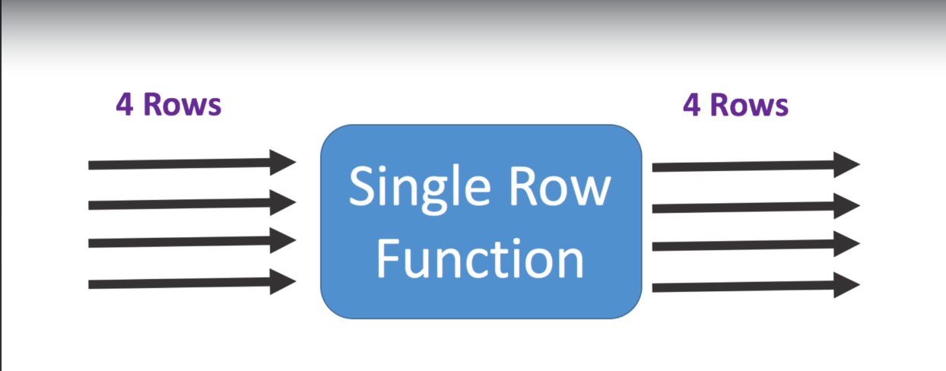

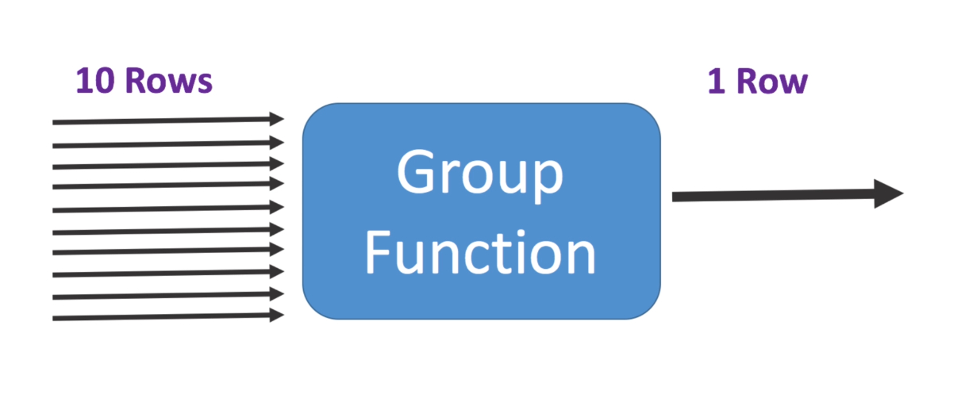

SELECT
CASE WHEN SUM(SAL)/COUNT(SAL) = AVG(SAL) THEN 'True' ELSE 'False' END AS Result
FROM EMP;

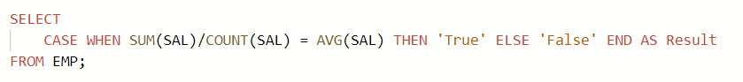

GROUP BY & HAVING


SELECT JOB, COUNT(JOB)
FROM EMP
GROUP BY JOB
ORDER BY COUNT(JOB) DESC;

SELECT JOB, COUNT(JOB), AVG(SAL)
FROM EMP
GROUP BY JOB
HAVING AVG(SAL) >= 3000;

